Communicating with stakeholders


***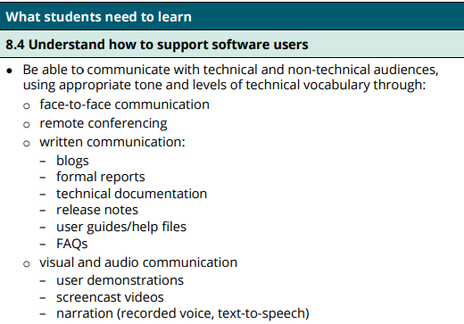
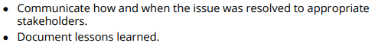

Proficiency | Content | To Do and Assessment | Help
💎 | Plenary | Please send your teacher a Teams message stating:  - Things that have gone well in your learning of late  - Things that you can do improve your learning
📚 | Notes | https://www.swiftdigital.com.au/blog/how-to-communicate-with-stakeholders/
🥈 | Watch video | https://www.youtube.com/watch?v=OyZCkbwzy2A | Using Platforms to Communicate with Stakeholders
🥉 | As we progress: Contribute to this Jamboard on today's content | https://jamboard.google.com/d/1bg_kwUkLnB909CTc0YkJdSfnhEPV7Xqs0z5-2H37Eaw/edit?usp=sharing | Add in explanations and examples. Show actual examples of the topic in action.  Add in a Quizlet to every jamboard  (could also add in pros and cons)
🏆 | Test | https://quizlet.com/719223333/test?answerTermSides=2&promptTermSides=6&questionCount=20&questionTypes=14&showImages=true  Topic Mastery Tracker.xlsx | Pls send Roger your results on Teams as a screenshot
 | Project work in applying your learning | Send me a screenshot of you applying the above techniques on the project program that you are currently developing.
 | Topic Tracker | Topic Mastery Tracker.xlsx | Helping you to assess your learning
🥇 | Review | Send your teacher a Teams message stating what you have learnt today
⭐⭐ | Extension Work | Update your workbook  Workbook.docx  Revision:  Update past workbooks  Master past assessments | Click on the link on the left. Send Roger a screenshot of todays work

Notes:
https://www.swiftdigital.com.au/blog/how-to-communicate-with-stakeholders/

